**Chapter 2: PROJECT MANAGEMENT**

**Topic – 1: Software Project Management (SPM)**

**Activities**

* Planning
* Implementation
* Monitoring
* Controlling

**Topic – 2: Management Spectrum**

**Diagram**

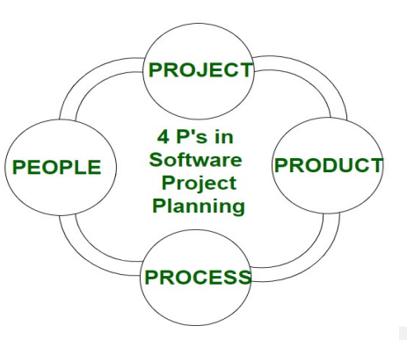

**People**

* Project manager
* Team leaders
* Stakeholders
* Analysts
* IT professionals etc

**Product**

* It is **project manager’s** responsibility to address the **technical hurdles** developers might face.
* Product can be **not** only that for any client, but also one that has to be introduced in the **company** itself.

**Process**

* Documentation phase
* Implementation phase
* Deployment phase
* Interaction phase

**Project**

* **Project manager** plays a critical role here.
* He/she is also responsible for **managing constraints** like cost and budget etc.

**Topic – 3: W5HH Principle**

**Introduction**

* This principle was given by **Barry Boehm**.
* It provides an **outline** for the project.

**W5HH Questions**

* Why the system is going to be developed?
* What activities are needed to be done in this?
* When will it be done?
* Who are responsible for the activities to be done in this project?
* Where are the people involved in the project located?
* How will the job be technically & managerially finished?
* How much part of each resource is required?

**Topic – 4: Software Project Planning**

**Elements Of Project Design**

* Project size
* Project cost
* Project duration
* Effort

**Order Of Project Planning Activities**

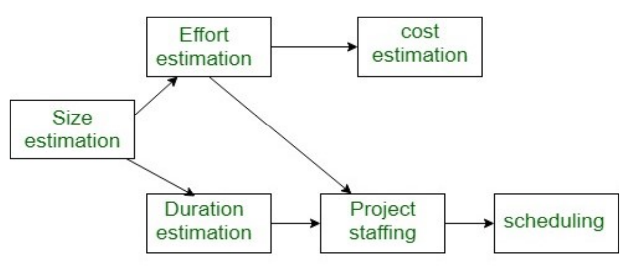

**Feasibility Study**

* **Feasibility:** The quality of being **doable**.

**Types Of Feasibility Study**

* **Technical feasibility:** If the available software & hardware can do the job.
* **Operational feasibility:** If operation & maintenance on product is doable.
* **Economic feasibility:** If it is economically possible for the company to carry the project.
* **Legal feasibility:** Legal consideration is taken at the project.
* **Schedule feasibility:** If project can be done on time.
* **Market feasibility:** If project will be successful in markets.

**Effort Estimation Methods**

* **Top-down estimation:** Deeply estimating the effort required in the project by breaking it down into various pieces, but **not** much accurate.
* **Bottom-up approach:** It is adding up all efforts from starting to end, comparatively **more** accurate.
* **Expert judgement:** Expert judges the estimation based on their experiences. Useful when dealing with a **unique** kind of project.
* **Analogous estimation:** Uses past data to know how projects worked out. Useful when dealing with usual projects.
* **Parametric estimation:** Uses mathematical models to calculate various parameters of the project.
* **Delphi technique:** Rather than one expert, a panel of experts make estimation.

**Quality Planning**

* Making project under **operational conditions**.
* Mostly used when the project is of **unique** type.

**Topic – 5: Risk Management**

**Introduction**

* Risks can include **employee sickness**, **inclement weather**, **unexpected costs** & **transportation delays** etc.
* Main factors affecting risks are **budget**, **scheduling** & **scope**.

**Steps Involved**

* Identification
* Assessment
* Control

**Topic – 6: Project Monitoring**

**Project Monitoring Plan**

* It is monitoring project’s **development** & **performance**.
* This is done to **ensure** that the project works fine as per its requirements.
* It can also ensure that various **risk factors** are **low**.
* **Project managers** & **stakeholders** see if it is working as expected.

**Importance Of Project Managing**

* Early detection of issues
* Real-time insights
* Keeps team engaged
* Keeps stakeholder engaged
* Proper resource utilization

**Project Monitoring Types**

* Progress monitoring
* Quality monitoring
* Risk monitoring
* Cost monitoring
* Performance monitoring

**Steps Involved**

* **Step 1:** Define monitoring objectives.
* **Step 2:** Obtain necessary information.
* **Step 3:** Examine & assess.
* **Step 4:** Take disciplinary actions.
* **Step 5:** Repeat

**Topic – 7: Software Development Projects**

**Types Of Software Projects**

* **Organic:** Application programs.
* **Semi-detached:** Utility software (compilers, linkers, DBMS etc).
* **Embedded:** System software.

**Differences Among Projects**

|  |  |  |
| --- | --- | --- |
| **Organic** | **Semi-detached** | **Embedded** |
| **2K to 50K lines of code.** | **50K to 300K lines of code.** | **>300K lines of code.** |
| **Small project** | **Medium project** | **Large project** |
| **Developers with good experience.** | **Developers with average experience.** | **Developers with little to no experience.** |
| **Less innovative** | **Medium innovative** | **Highly innovative** |

**Topic – 8: COCOMO Model**

**Introduction**

* **COCOMO** stands for **Constructive** **Cost Effective Model**.
* Done through **3** stages: **Basic COCOMO**, **intermediate COCOMO** & **complete COCOMO**.

**Basic COCOMO Model**





**Tdev = Estimated time to develop the software (in months)**

**Effort = Effort required to develop the software (in person months)**

**Constants in formulae above:**

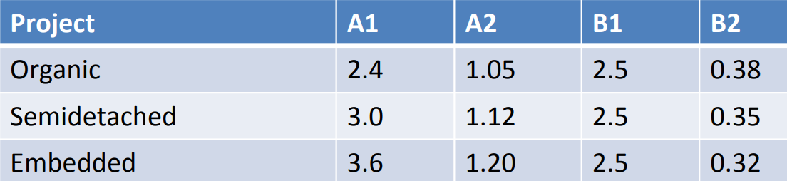

**Warning!**

**🡪 100 PM doesn’t mean that 1 person should work for 100 months.**

**🡪 100 PM also doesn’t mean that 100 people should work for 1 month.**

**🡪 Even if a line of code contains multiple instructions, it must be considered single line of code.**

**Intermediate COCOMO Model**

* Takes **other factors** into the account.
* These factors/attributes are called ***cost drivers***.
* **Cost drivers** include **computer**, **product**, **personal**, **development environment** etc.

**Complete COCOMO Model**

* It acknowledges the fact that a software is developed from **multiple sub-software** developed separately.
* So, the cost estimation of each of these sub-software/sub-systems are **estimated separately** & then **summed up**.